TITLE OF THE ARTICLE IN TIMES NEW ROMAN 12 POINT
Vishal Thakur¹, Sumit Singh², Neeraj Kohli³,Sagar Dwivedi⁴
¹⁻³Department of Mechanical Engineering
XYZ Institute
⁴Department of MechanicalEngineering
XYZ Institute

ABSTRACT
Just few lines describing the outline of the work.
The paper is to be typed on A4 sheet with 1 inch margin all sides.
The tile of the article in Times New Roman 14 points.
The remainng aticle is in Times New Roman 12 points.
Tables are in Times New Roman 9 points.
There is a limit to maximum length of the article, it is 10 pages

NOMENCLATURE
(Sample)
BSA: Bovine serum albumin
CPC: Calcium phosphate paste
DMD: Digital micromirror device based 3D printing
ECM: Extracellular matrix

- INTRODUCTION
Introduction of the work carried out. Use reference style as shown in the lines below.
The idea of tissue engineering and regeneration was introduced by Langer and Vacandi in 1993. It was at that time, that the idea of 3D scaffolds were studied in details and published in the form of research paper (Loh and Choong, 2014).

- BACKGROUND AND REVIEW
A brief background and the review of the work.
(Sample)
Metals provide a potential option for 3D printing of scaffolds. They are high on mechanical strength similar to that of a bone. Stainless steel, titanium and its alloys, cobals-chromium alloys etc are highly used for such processes. Maleksaeedi et al (2013) made use of titanium for making the scaffolds using 3D inkjet printing. Farzadi et al (2015) made use of calcium sulphate powder for scaffold designing. Feilding et al (2011) used tricalcium phosphate instead. They made scaffolds with a commercial 3D printer. Analysis was performed by XRD and surface morphology was examined by FESEM. Thus the addition of SiO₂ and ZnO dopants to the TCP scaffolds showed increased mechanical strength as well as increased cellular proliferation

- FABRICATION TECHNIQUES FOR SCAFFOLDS
3.1 Heat mediated 3-D fabrication
(Sample)
Fabrication by heat energy combines pre-fabricated polymer layers into simple threedimensional structures by raising the polymer above its glass transition temperature and fusing the softened layers together with applied pressure (Yang et al, 2002). In sheet lamination fabrication, laser-cut polymer sheets are sequentially bonded by the application of heat and pressure. Currently, scaffolds created with this method have very low void volume and are generally too dense for the construction of tissues with high cellularity (refer Table 1).

Table 1. Characterization of 3D printing techniques according to the form of material
Form Examples | Printing processes | Suitable 3D machine
Solidifiable fluid | Photopolymer resins, temperature sensitive polymers, ion cross-linkable hydrogels, ceramic paste, etc. | Stereolithography (SLA)  Polyjet  Digital light processing (DLP)  Micro-extrusion
Non-brittle filament | Thermoplastics, e.g., ABS, PLA, and PCL | Fused deposition modelling (FDM)
Laminated thin sheet | Paper, plastic sheet, metal foil | Paper lamination technology (PLT)  Laminated object manufacturing (LOM)  Ultrasonic consolidation (UC)
Fine powder | Plastic fine powder, ceramic powder, metal powder | Selective laser sintering/melting (SLS/SLM)  Electron beam melting (EBM)  Laser engineered net shaping (LENS)  Direct metal deposition (DMD)  Colorjet printing (CJP)

- OUTCOME OF LITERATURE REVIEW
(Sample)In the second decade after the birth of tissue engineering, 3D printing gradually became a definite part of this field, due to its controllability and manufacturing capability. Looking into the future, even once the technical challenges described above are overcome; it will still be a long way from transforming academic know-how into clinical products that benefit society. Researcher’s current tasks in the field are to accelerate the standardization and certification of 3D printed medical devices(refer Figure 1).
Figure 1. machines
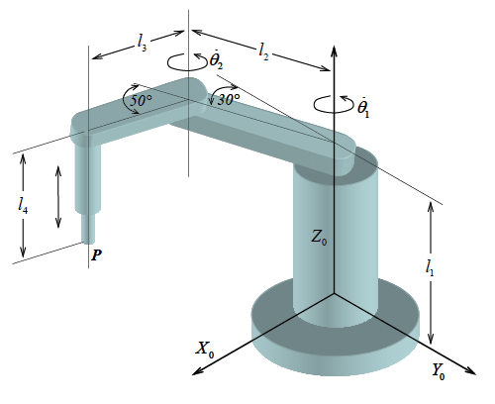

- OBJECTIVES OF RESEARCH
(Sample)3D scaffolds play an important role in the success of tissue engineering. Well connected porosity, size of the pores are important contributors for cell growth. Many different materilas have been devleoped, tried and test for different medical applications by the researcher in the past. With the advacnement of new printing technologies and new materials beings developed there is a need to investigate 3D scaffolds for improvement in properties.
Following objectives for the study have been formaultated:
- Developing new materials, bioinks and novel printing methods for 3D printing of scaffolds.

- METHODOLOGY

- MODELLING/EXPERIMENTATION

- CONCLUSIONS

REFERENCES(Sample)
Aboulkhair N T, Everitt N M, Ashcroft I, Tuck C (2014) "Reducing porosity in AlSi10Mg parts processed by selective laser melting" Additive Manufacturing, 1, 77–86.
Akkineni A R, Luo Y, Schumacher M, Nies B, Lode A, Gelinsky M (2015) "3D plotting of growth factor loaded calcium phosphate cement scaffolds" Acta Biomaterialia, 27, 264–274.
Ang T H, Sultana F S A, Hutmacher D W, Wong Y S, Fuh J Y H, Mo X M, Teoh S H (2002) " Fabrication of 3D chitosan-hydroxyapatite scaffolds using a robotic dispensing system." Materials Science and Engineering C, 20(1-2), 35–42.
Loh Q L, Choong C A. (2014) " Molecular Plant-Microbe Interactions : MPMI" 1–61.
Billiet T, Gevaert E, De Schryver T, Cornelissen M, Dubruel P (2014) "The 3D printing of gelatin methacrylamide cell-laden tissue-engineered constructs with high cell viability." Biomaterials, 35(1), 49–62.
Butscher A, Bohner M, Roth C, Ernstberger A, Heuberger R, Doebelin N (2012) " Printability of calcium phosphate powders for three-dimensional printing of tissue engineering scaffolds." Acta Biomaterialia, 8(1), 373–385.

